**ANALYZING BUSINESS DATA IN SQL**

# Course Overview

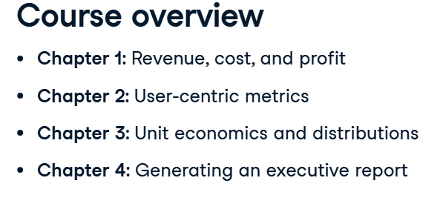



# Revenue, Cost and Profit

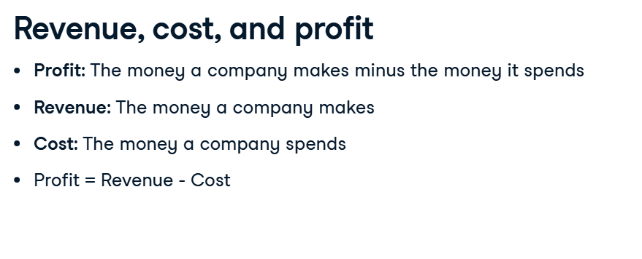

## Tables for Revenue

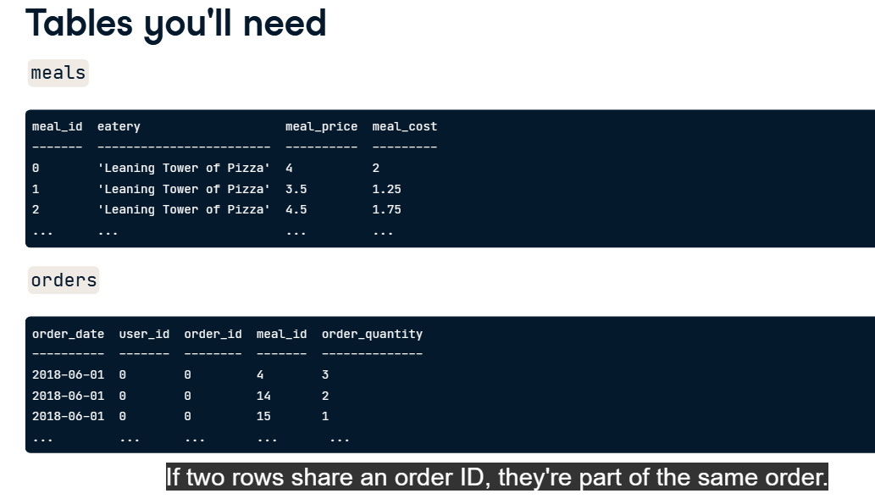

## Calculating Revenue

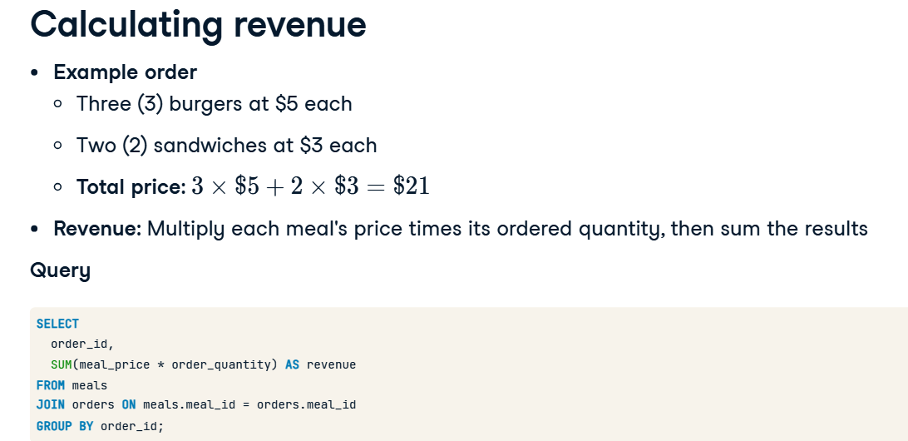

## Working with dates

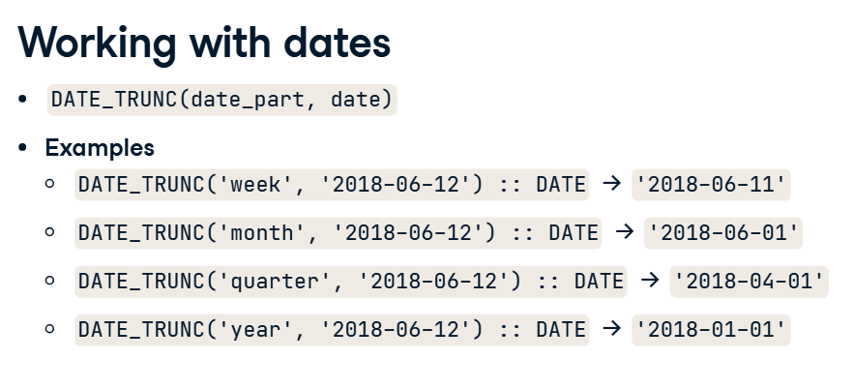

## Calculate weekly revenue for June 2018

SELECT DATE_TRUNC('week', order_date) :: DATE AS delivr_week,

       -- Calculate revenue

       SUM(meal_price * order_quantity) AS revenue

  FROM meals

  JOIN orders ON meals.meal_id = orders.meal_id

-- Keep only the records in June 2018

WHERE DATE_TRUNC ('month', order_date) = '2018-06-01'

GROUP BY delivr_week

ORDER BY delivr_week ASC;

## Cost

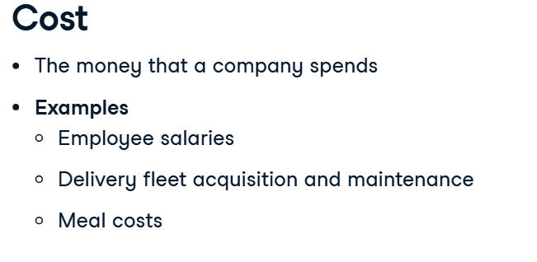

## Tables for Cost

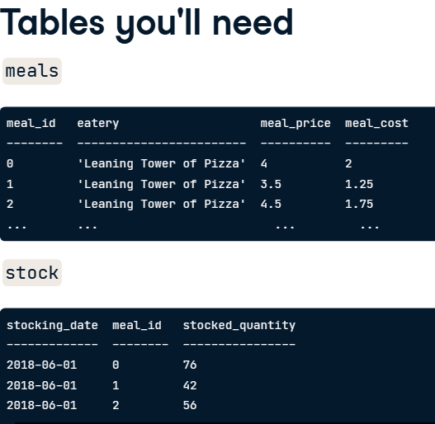

## Calculating Cost

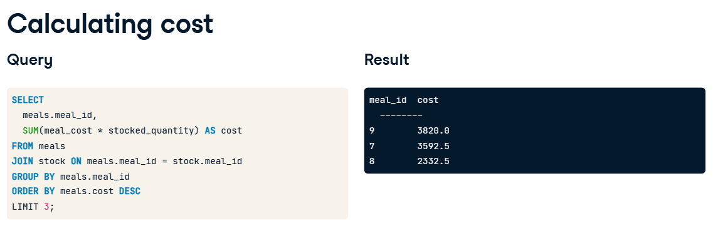

## Combine Revenue and Cost - Common Table Expressions (CTEs)

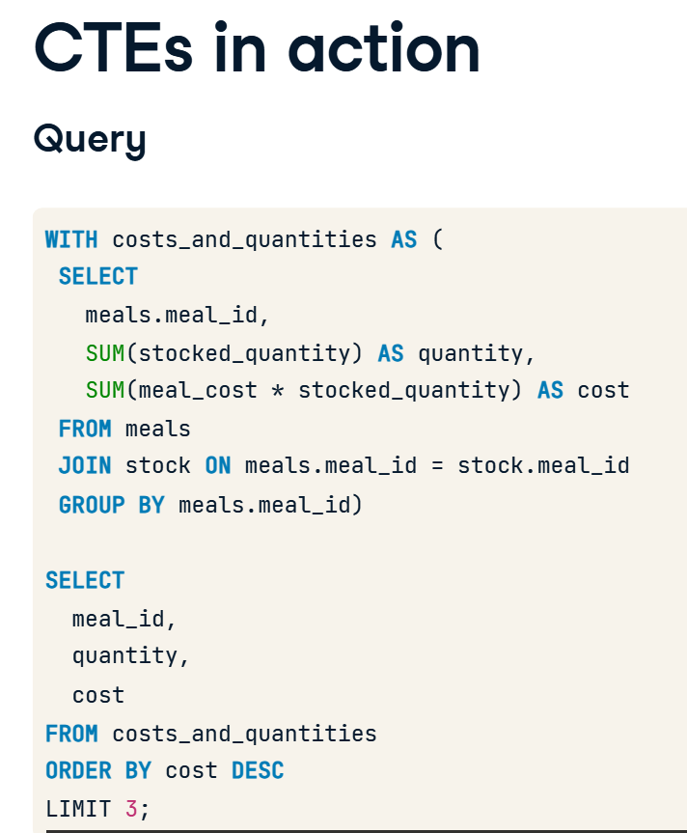

## Query to calculate cost per month

SELECT

  -- Calculate cost

  DATE_TRUNC('month', stocking_date)::DATE AS delivr_month,

  SUM (meal_cost * stocked_quantity) AS cost

FROM meals

JOIN stock ON meals.meal_id = stock.meal_id

GROUP BY delivr_month

ORDER BY delivr_month ASC;

## How much Delivr spent per month on average during its early months (before September 2018)

-- Declare a CTE named monthly_cost

WITH monthly_cost AS (

  SELECT

    DATE_TRUNC('month', stocking_date)::DATE AS delivr_month,

    SUM(meal_cost * stocked_quantity) AS cost

  FROM meals

  JOIN stock ON meals.meal_id = stock.meal_id

  GROUP BY delivr_month)

SELECT

  -- Calculate the average monthly cost before September

  AVG(cost)

FROM monthly_cost

WHERE delivr_month < '2018-09-01';

## Profit

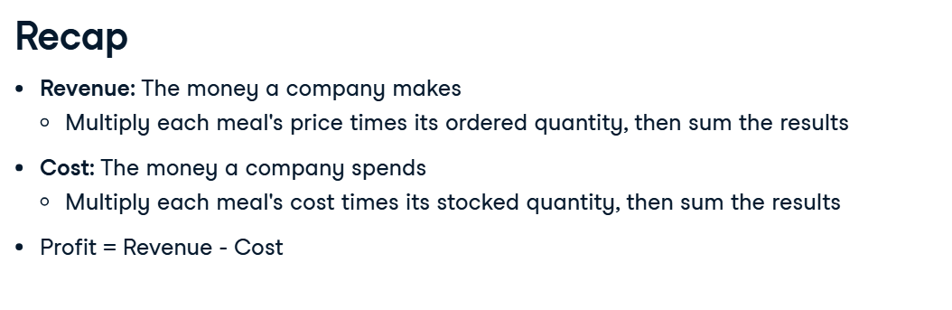

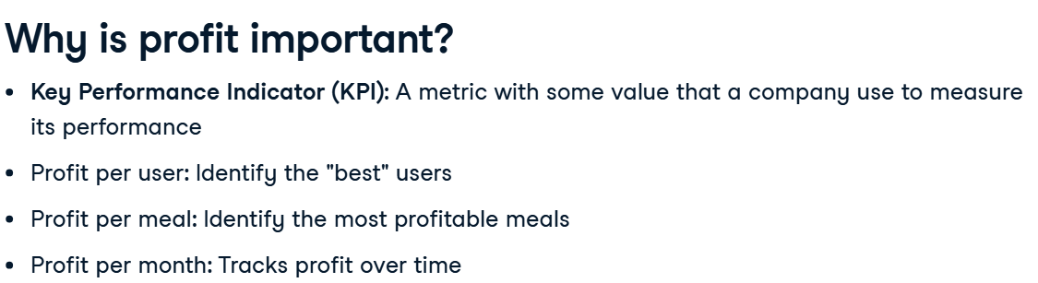

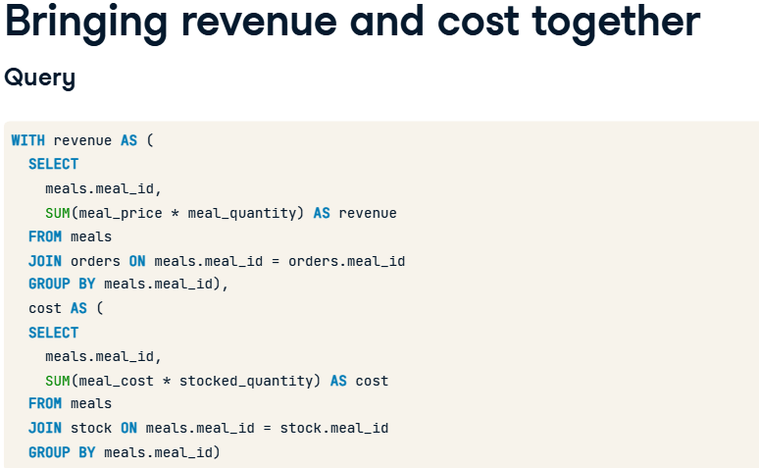

**If you're calculating profit per some other metric, like eatery or month, make sure to group by that metric in both CTEs, since you'll join the two CTEs on that metric's column later on.**

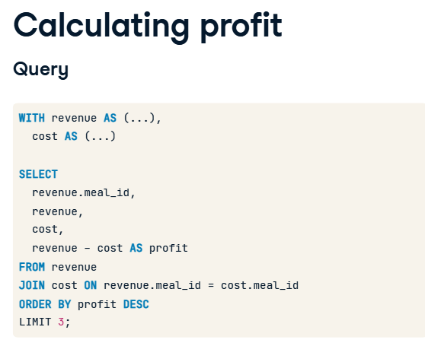

## How much profit each eatery is generating

WITH revenue AS (

  -- Calculate revenue per eatery

  SELECT eatery,

         SUM(meal_price * order_quantity) AS revenue

    FROM meals

    JOIN orders ON meals.meal_id = orders.meal_id

   GROUP BY eatery),

  cost AS (

  -- Calculate cost per eatery

  SELECT eatery,

         SUM(meal_cost * stocked_quantity) AS cost

    FROM meals

    JOIN stock ON meals.meal_id = stock.meal_id

   GROUP BY eatery)

   -- Calculate profit per eatery

   SELECT revenue.eatery,

          revenue - cost AS profit

     FROM revenue

     JOIN cost ON revenue.eatery = cost.eatery

    ORDER BY profit DESC;